Spark Basic Architecture

Introduction
Apache Spark is a distributed data processing framework designed for fast and large-scale data processing. Its architecture follows a master-slave pattern, where a central driver coordinates multiple worker nodes. The core components of Spark architecture include the Cluster Manager, SparkSession, SparkContext, Driver Node, Worker Node, and execution modes (Client and Cluster Mode)

1. Cluster Manager
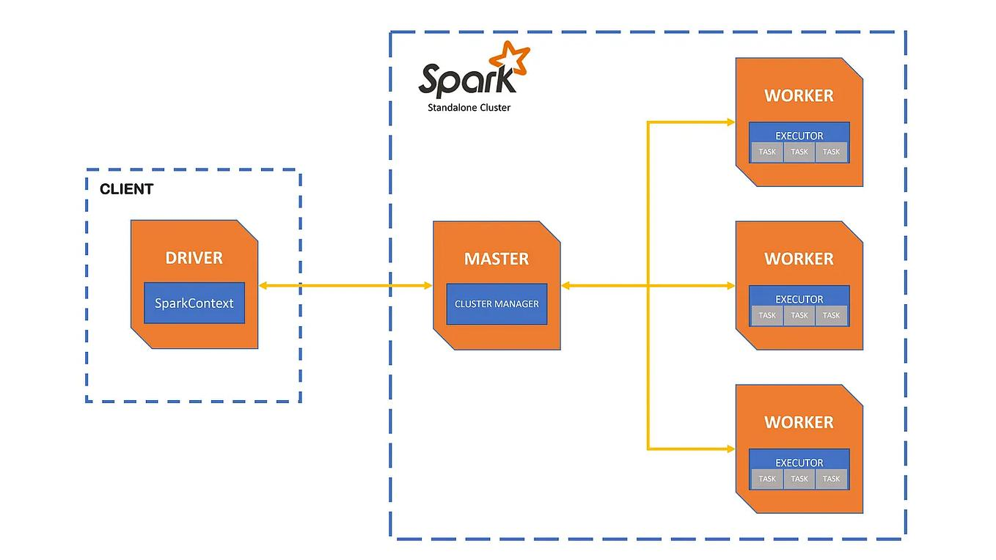

The Cluster Manager is responsible for managing resources across the cluster. It acts as an intermediary between Spark applications and the available hardware resources.

Responsibilities:
- Allocates CPU and memory resources to applications
- Schedules tasks on worker nodes
- Monitors resource usage across the cluster
- Supports multiple applications running simultaneously

Types of Cluster Managers:
- Standalone – Built-in Spark manager, simple to configure
- YARN – Commonly used in Hadoop environments
- Kubernetes – Container-based cluster management
- Mesos – General-purpose distributed system manager

Key Points:
- Ensures efficient resource utilization
- Enables scalability and load balancing
- Supports fault tolerance by reallocating tasks

2. SparkSession
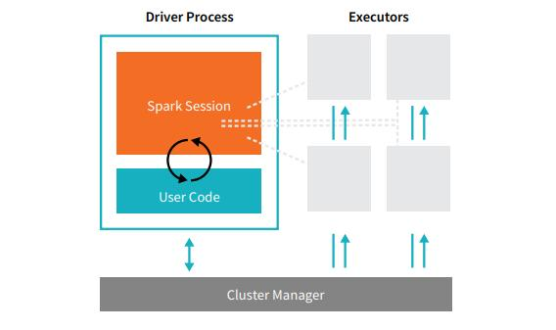

The SparkSession is the unified entry point for interacting with Spark. It allows users to create DataFrames, execute SQL queries, and configure Spark applications.

Responsibilities:
- Initializes Spark applications
- Provides APIs for structured data processing
- Manages configuration settings

Key Points:
- Introduced in Spark 2.0
- Combines SparkContext, SQLContext, and HiveContext
- Supports SQL, DataFrames, and datasets
- Allows integration with Hive

Example:
from pyspark.sql import SparkSession
spark = SparkSession.builder.appName("MyApp").getOrCreate()

3. SparkContext

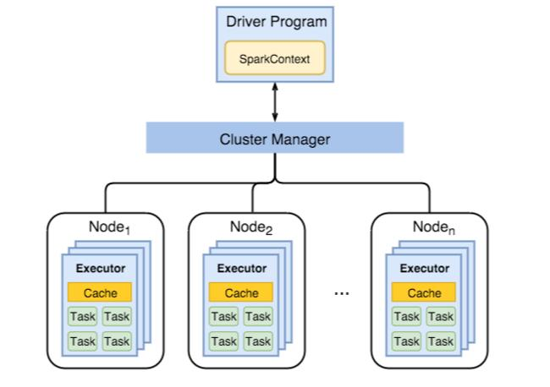

The SparkContext is the core component that establishes the connection between the Spark application and the cluster.

Responsibilities:
- Connects to the cluster manager
- Creates RDDs (Resilient Distributed Datasets)
- Distributes tasks to worker nodes
- Monitors execution of jobs

Key Points:
- Only one SparkContext per application
- Converts operations into jobs, stages, and tasks
- Supports broadcast variables and accumulators
- Works primarily with RDD-based APIs

Concepts:
- Transformation – Lazy operations (e.g., map, filter)
- Action – Triggers execution (e.g., collect, count)

4. Driver Node

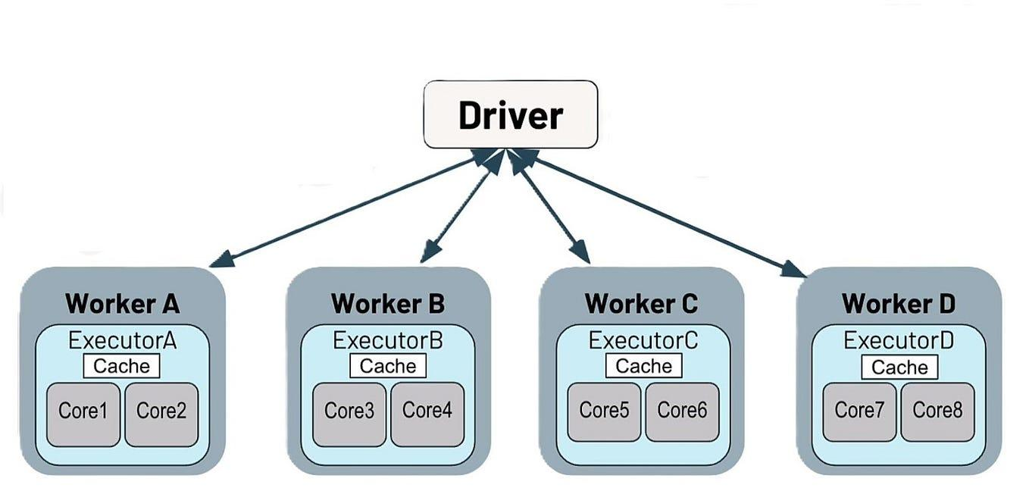

The Driver Node is the central controller of a Spark application. It executes the main program and coordinates all operations.

Responsibilities:
- Converts user code into a DAG (Directed Acyclic Graph)
- Divides DAG into stages and tasks
- Schedules tasks on executors
- Collects and returns results

Key Points:
- Contains DAG Scheduler and Task Scheduler
- Maintains metadata about jobs and datasets
- Handles fault recovery and retries
- Failure of driver leads to application failure

5. Worker Node

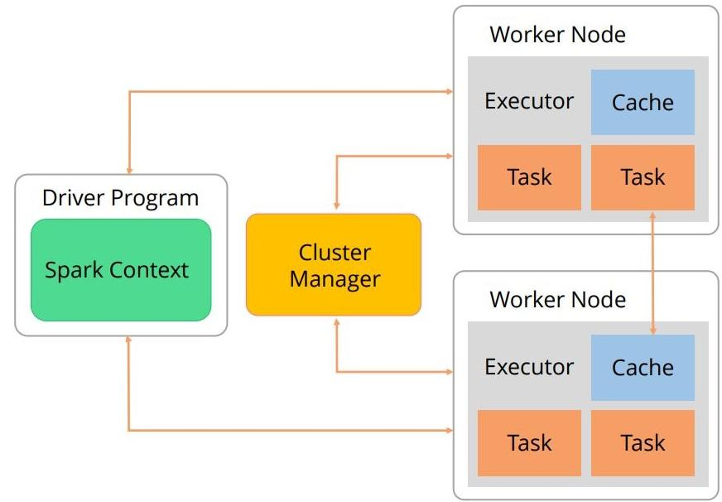

The Worker Node is responsible for executing the tasks assigned by the driver.

Responsibilities:
- Runs executors
- Processes data and executes tasks
- Stores intermediate and final results

Key Points:
- Each worker can run multiple executors
- Supports parallel task execution
- Provides in-memory computation for faster processing
- Handles caching and persistence of data

6. Client Mode

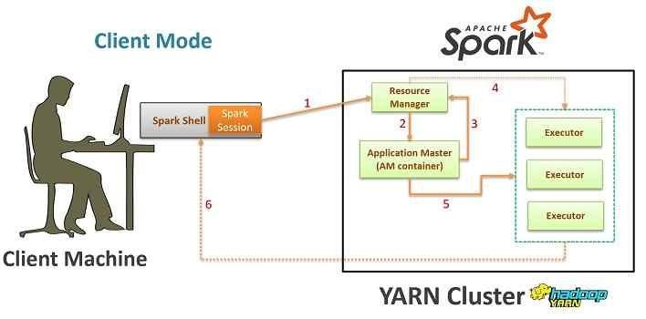
In Client Mode, the driver runs on the local machine from which the application is submitted.

Characteristics:
- Driver runs outside the cluster
- Executors run within the cluster
- Requires stable network connection

Advantages:
- Easy debugging and monitoring
- Suitable for development and testing

Disadvantages:
- Dependency on client machine
- Lower fault tolerance
- Network latency can impact performance

7. Cluster Mode

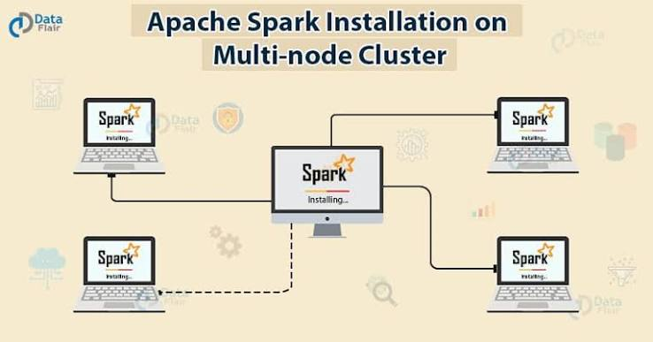

In Cluster Mode, the driver runs inside the cluster on one of the worker nodes.

Characteristics:
- Entire application runs within the cluster
- No dependency on client machine

Advantages:
- High fault tolerance
- Better performance for large-scale jobs
- Suitable for production environments

Disadvantages:
- Harder to debug
- Logs are not directly available on local machine

Conclusion
Apache Spark’s architecture is designed for scalability, speed, and fault tolerance. The Driver Node coordinates execution, Worker Nodes process data, and the Cluster Manager efficiently allocates resources. SparkSession and SparkContext provide interfaces to interact with the system, while Client and Cluster modes determine how applications are deployed. Understanding these components is essential for building efficient big data solutions.

